/*
* Chris Tjon, Ex. 4.3, Wed 4pm
*
* Calculate the average of two values to 1 decimal place
*/
package average;

import java.applet.Applet;
import java.awt.Graphics;

public class Average extends Applet
{
public void paint(Graphics g)
{
int mark1 = 44;
int mark2 = 51;
float average;

average = (float)(mark1 + mark2) / 2; // cast the addition to get float result
g.drawString("Average = " + average, 50, 50);
}
}

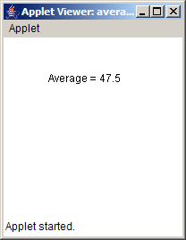

/*
* Chris Tjon, Ex 4.7 Wed 4pm
*
* Program to translate 2549 seconds into hours, minutes, and seconds
*/
package time_conv;

import java.applet.Applet;
import java.awt.Graphics;

public class TimeConv extends Applet
{
public void paint(Graphics g)
{
int totalSeconds = 2549;
int hours;
int minutes;
int seconds;
int remainder;

hours = totalSeconds / 3600; //3600 seconds/hr
remainder = totalSeconds % 3600; //how many seconds left for min:sec
minutes = remainder / 60; //60 seconds/min
seconds = remainder % 60; //remainder is :sec

//Do the output
g.drawString("Hours = " + hours, 50, 50);
g.drawString("Minutes = " + minutes, 50, 70);
g.drawString("Seconds = " + seconds, 50, 90);
}
}

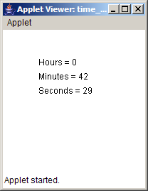
/*
* Chris Tjon, Ex 5.2, Wed 4pm
*
* Draw a street of 4 houses 10 pixels apart
*/
package drawhouses;

import java.awt.*;
import java.applet.Applet;

public class DrawHouses extends Applet
{
public void paint(Graphics g)
{
drawStreet(g, 30, 50, 50);
}

private void drawStreet(Graphics g, int wallHeight, int bottomX, int bottomY)
{
int i;
int gap = 10;
int width = wallHeight;
int numHouses = 4;

for (i = 0; i < numHouses; i++)
{
drawHouse(g, (bottomX + (width * i) + (gap * i)), bottomY, width, wallHeight);
}
}

private void drawTriangle(Graphics g, int bottomX, int bottomY, int base, int height)
{
g.drawLine(bottomX, bottomY, bottomX + base, bottomY);
g.drawLine(bottomX + base, bottomY, bottomX+base/2, bottomY - height);
g.drawLine(bottomX+base/2, bottomY - height, bottomX, bottomY);
}

private void drawHouse(Graphics g, int bottomX, int bottomY, int width, int height)
{
g.drawRect(bottomX, bottomY-height, width, height);
drawTriangle(g, bottomX, bottomY-height, width, height/2);
}
}
}
